Pennsylvania Commission on Crime and Delinquency (PCCD)
Grantee Outcomes Report Template

As a requirement of funding under PCCD’s Research-based Programs Initiative, all grantees are required to submit a cumulative outcomes report. Grantees should begin working on this report during quarter 3 of year 2 of funding. The final Outcome Report needs to be submitted into E-grants in quarter 4 of year 2 of funding.
The purpose of the Outcomes Report is to convey the experience of the grantee in implementing the program, and to summarize the program’s reach, implementation quality, and impact. Preparing the Outcomes Report is intended to be a reflective process and can also serve as a valuable tool to the grantee for communicating the program’s impact to local stakeholders.
It is recommended that prior to completing the report, grantees print copies of their grant application, quarterly E-grants reports, excel spreadsheet PM reporting tool(s), and other program data. These resources should be used to respond in narrative format to all of the outcome report questions. Please answer using complete sentences.
Please only report on data that is reflective of participants and services funded by PCCD. If multiple grants have been funded, separate outcome reports are required for each grant.
A document providing guidance on how to complete the report for your specific program can be accessed on the EPIS website at: www.epis.psu.edu. Please contact your assigned EPIS Prevention Coordinator by phone at 814-863-2568 if assistance is needed. You are strongly encouraged to submit your draft report to your assigned EPIS Prevention Coordinator for feedback prior to submitting the report to PCCD. The final report should be attached in E-grants with your quarterly report in the 4th quarter of year 2.

Person Completing the Report (name, phone, & email):

Grant ID #:
Grantee’s Name:
Evidence-based Program Implemented:
Grant Start Date:
Report Completion Date:
Geographic Location (County/School(s) Served):

Describe any major changes to the project plan from what was originally proposed, and why those changes were necessary. If a Project Modification Request (PMR) was submitted, please explain. You may simply copy and paste the description and justification from the PMR as your description here.

INSERT AGENCY LOGO

PROJECT TND OUTCOMES SUMMARY
In 2012, funds were awarded from the Pennsylvania Commission on Crime and Delinquency for two years of program implementation. This report summarizes the results through (indicate data timeline).

Additional Participants to be Served by the Grant’s End: We plan to serve an additional 200 students.
School Population Characteristics: Local info here
Description of the Targeted Risk and Protective Factors: Local info here

MODEL FIDELITY HIGHLIGHTS: Project TND fidelity is assessed by observing 20% of the lessons taught. In addition, a Quality Assurance review is conducted by the program developer after the first full year of implementation.
Facilitation Strengths and/or Areas for Improvement: Local info here.
Student Engagement: The TND Post-test includes four process questions to assess level of student engagement which is a key factor in achieving desired outcomes. ZZ% of Project TND students reported a high level of engagement.
Why is Model Fidelity important?
“Evidence Based” programs are proven to get high quality outcomes for youth, families, and communities. However, these programs only predictably produce quality outcomes when they are implemented as they were designed by the researchers who developed them, with fidelity to the model.

Project TND Substance Abuse Prevention Outcomes
Project TND Youth Survey Administration: The data shown below was collected using a 31 item survey adapted from a tool used in the original Project TND research. It is completed by each youth before the first TND lesson and then again after the 12th lesson. The tool assesses changes in knowledge, skills, and substance use intentions. The post tool has an additional section that assesses level of student engagement in the TND lessons.
Total Number of Participants Surveyed: Local data here. Enter the Number of youth surveyed out of the number of youth served. Ex. 335 youth out of 355 served, or 94% completed the pre/post surveys.

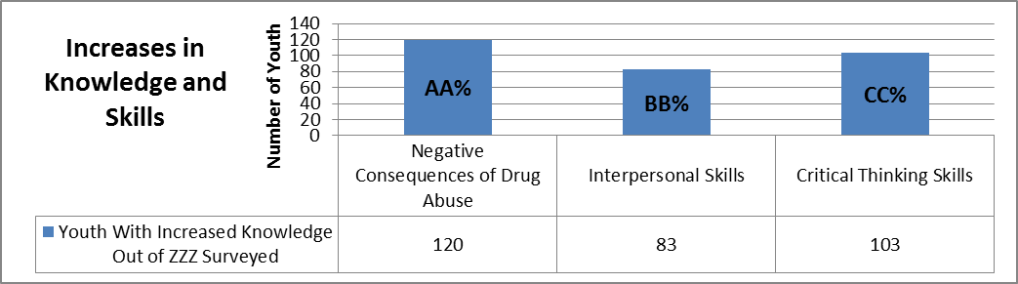
What is the expected long-term impact of Project TND? The outcomes highlighted above reflect short-term participant changes in knowledge, motivation, and skills. These changes are expected to lead to long-term outcomes similar to those demonstrated in Project TND trials.
Potential Long-Term Impacts of Project TND Shown in Randomized Control Trials
- 27% prevalence reduction in 30-day cigarette use
- 22% prevalence reduction in 30-day marijuana use
- 26% prevalence reduction in 30-day hard drug use
- 9% prevalence reduction in 30-day alcohol use among baseline drinkers
- 25% prevalence reduction in one-year weapon-carrying among males

What is the Cost Benefit of Project TND? The Washington State Institute for Public Policy reports that for every dollar invested in Project TND there is a potential savings of $8.61 or $109 for every youth who participates.

With 355 youth completing Project TND lessons there is a potential savings of $38,695 for the community!

SECTION 1 – DESCRIPTION OF POPULATION SERVED

- Please explain if you are serving or expect to serve the number of participants targeted in your grant application (why or why not). Refer to the chart listing your original target and the total number served.

- Describe your recruitment and referral process for the program:

List your referral sources:

Explain any barriers to recruitment or referrals:

- Please explain whether or not you implemented the program as designed and with the indicated dosage (i.e. hours of service, number of lessons delivered, number of mentoring hours, number of sessions):

Referring to the chart of participant attendance, please provide an explanation for participants not receiving the full dosage:

SECTION 2 - INDICATORS OF PROGRAM IMPACT

Total Number of Participants: | Number of Participants Surveyed: | Percentage of Participants Surveyed:

- Explain any challenges you encountered in collecting or analyzing survey data. Include an explanation for the percentage of participants not surveyed:

- Explain any factors that you feel may have influenced the outcomes data results:

- Indicate the baseline community level indicators that led to the selection of your program (i.e., PAYS data, child abuse rates, juvenile court or probation statistics, school dropout rates, etc.).

State your plan for tracking long-term change in community level indicators:

SECTION 3 – INDICATORS OF IMPLEMENTATION QUALITY AND FIDELITY

- Explain any barriers to the fidelity assessment process that were encountered and how you did or plan to overcome them:
Note: Please include any changes made to the assessment process during the grant cycle in your response.

- Describe specific processes for providing assessment results or feedback to implementers to support continuous quality improvement:

- Indicate any areas of strength in implementation quality or fidelity that were identified from reviewing your fidelity data or during the Quality Assurance Process:

- Indicate any challenges in implementation quality or fidelity that were identified when reviewing your fidelity data or during the Quality Assurance Process:

Explain any changes you made throughout the grant cycle to your implementation in response to the challenges identified:

SECTION 4 - LESSONS LEARNED

- Describe anything you would have done differently during grant planning or implementation to improve the program’s coordination, delivery, or effectiveness:

- What lessons have you learned that would benefit other communities who are considering implementing this program:

- Please describe any ways in which you exceeded the expectations of the project as proposed or realized additional benefits for your community:

SECTION 5 - PROGRAM SUSTAINABILITY

- Explain the specific planning steps have you taken to sustain the program beyond PCCD funding (e.g., detailing the budget, meeting with stakeholders, securing local investment, applying for additional grants):

- If you have applied for or secured additional funding from any source to support the program, please list the source(s) and the status of any pending application(s):

THANK YOU FOR YOUR TIME!

